

Unlocking The Niche Code

(How to Research the Moneymaking Capabilities of a Niche)

A Step-by-step Approach to Finding the Best Niches in which to Market a Product or Service

Unlocking The Niche Code:

When selling a product, a lot of people make the mistake of developing their product first, and then trying to find a market for it. Of course, the process should be reversed.

Find a market first that spends money, then find out what they want and give it to them.

It is certainly easier said than done, but there are a lot of places online where you can do your market research for free. They've done most of the work for you already. You just need to know where to go and what to do to connect all the dots.

Let me show you the process I go through when I'm trying to brainstorm for ideas.

For starters, I'm always aware of trends and current events in the real world. I read several newspapers each day, many magazines, both general and niche-specific, I watch the news, I listen to the radio. Occasionally something that I hear or read will stick with me. I may record my thoughts on my portable voice recorder; jot down some notes, whatever happens to be convenient for me. Sometimes I'll call my office voice mail and leave myself a message.

But at some point I'll have several broad ideas to research. I want to look deeper. And I want to make sure there is a good market for them before I even think about creating a product.

So I'll begin completing the following steps:

Google Zeitgeist-
http://www.google.com/press/zeitgeist.html

To begin with, I check out the hottest search trends at Google Zeitgeist. If I am targeting the US market, I’ll click on “U.S. Zeitgeist,” otherwise I’ll look at “Zeitgeist Around the World.” At this point I am just looking for ideas.

If I see that a particular topic is hot, I’ll make a note of it and look at more targeted sub-niches later on at more specialized sites (which I’ll show you shortly).

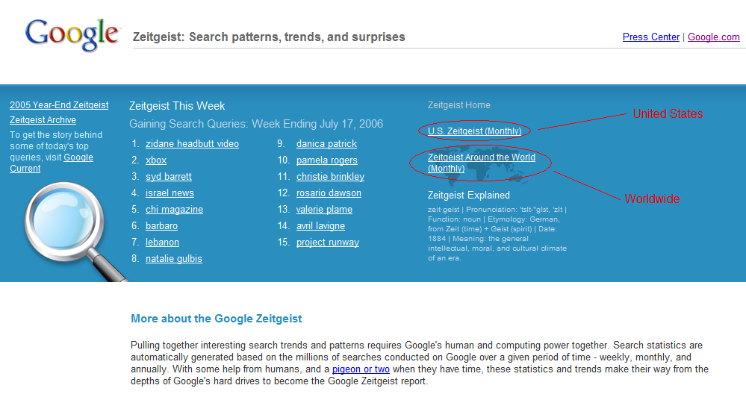

Lycos Top 50 - http://50.lycos.com

The Lycos Top 50 is another site, like Google Zeitgeist, where I will review the latest trends and look for hot topics to explore further. I will also look at Yahoo! Buzz for ideas as well (see below).

Yahoo! Buzz - http://buzz.yahoo.com

eBay Pulse – http://pulse.ebay.com

The eBay Pulse site is a great place to start looking at sub-niches. What I will do is select the category first (using the topics I’ve gathered from looking at the previous sites), then look for profitable sub-niches by then selecting a sub-category.
The best chance for success is if I am as specific as possible with my niche selection. In the example below, I don’t want to sell to the “crafts” niche.
I want to sell to grandmothers who enjoy giving their latch rug hooking gifts to their families and friends. Whatever. You get the idea.

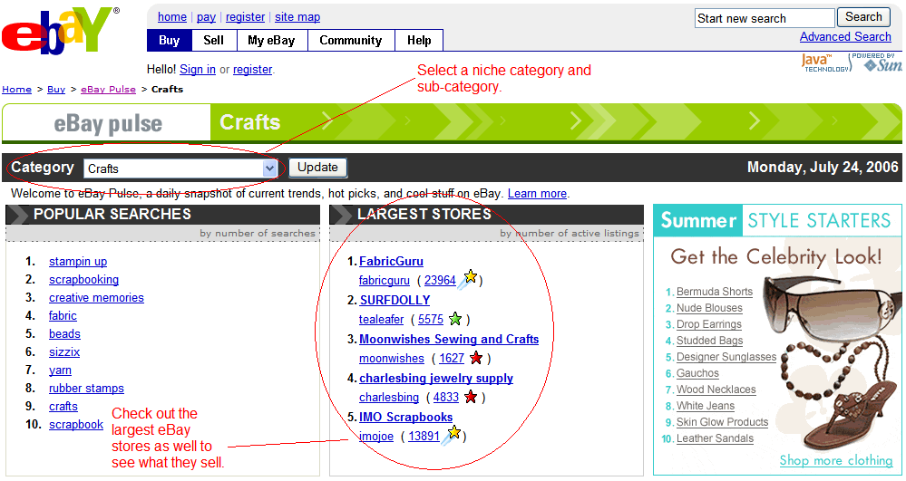

Also, I’ll always check the largest stores as well to see what they’re selling. There has to be a reason they are the largest stores. They must be doing something right.

eBay also puts out a PDF report of their hottest categories each month, available at
http://pages.ebay.com/sellercentral/hotitems.pdf.

Now that I have some potential sub-niches to work with, I want to see how much of a market there is there.

Just because a sub-niche is popular doesn’t mean people spend money on it.
Amazon - http://www.amazon.com

Amazon is a great place to see what currently exists for any given sub-niche.

Chances are, the more books there are written on that subject, the more that market spends on those topics.

For example:

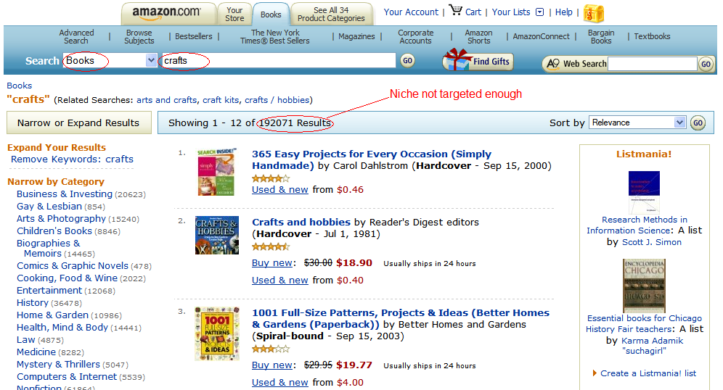

First I specify “Books” to search. Then I enter my niche, in this case “crafts.”

Uh oh. There are WAY too many books returned. This niche is not targeted enough. It is too “mainstream.”

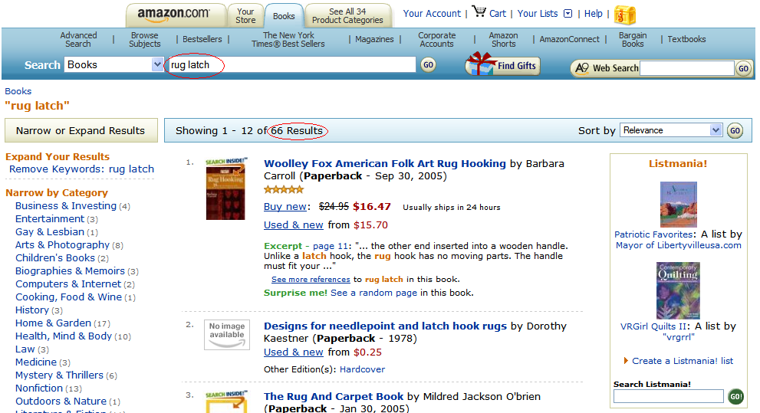

Much better! There are possibilities here.

We now suspect the following:

- This sub-niche may be targeted enough.

- This sub-niche may spend money.

Time to scope it out a little further.

We want to be as certain as we possibly can that our niche is focused enough but big enough, and that the people in that niche spend money.

So next I head over to the Overture Resource Center (http://searchmarketing.yahoo.com/rc/srch) and click on the “Keyword Selector Tool.”

Then I enter my niche and see how many times that keyword and all related keywords were searched in the previous month.

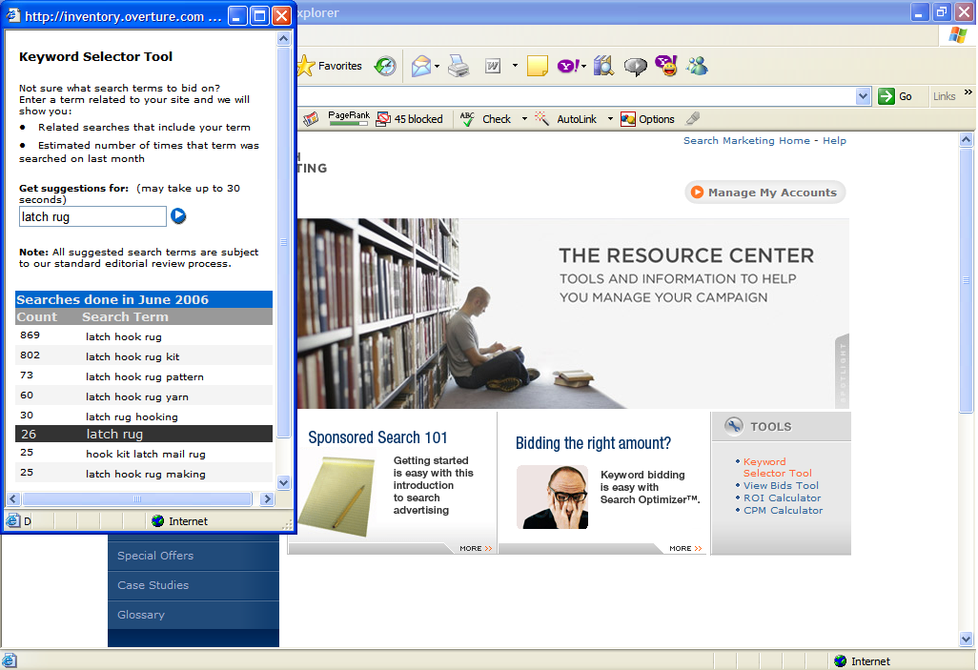

I like to see at least 10,000 searches for all keywords combined, but not more than, say, 50,000 or so (although I do have profitable niches that have only a few thousand searches at Overture, but they are the exception rather than the rule).

For “latch rug”, you can see that this market is just too small.

Remember that Overture searches are for Yahoo and their partner sites, so to measure the number of searches on Google, I usually estimate between 5 and 10 times this number to come up with Google’s searches. Also, depending on the market, I've sometimes found Overture’s figures somewhat inflated, so bear in mind that the number of actual searches might be lower.

If I’m happy with the number of searches for this potential niche, I next want to see how much pay per clicks (PPC) are going to cost me on Google Adwords.

For that I use Overture’s “View Bids Tool.”
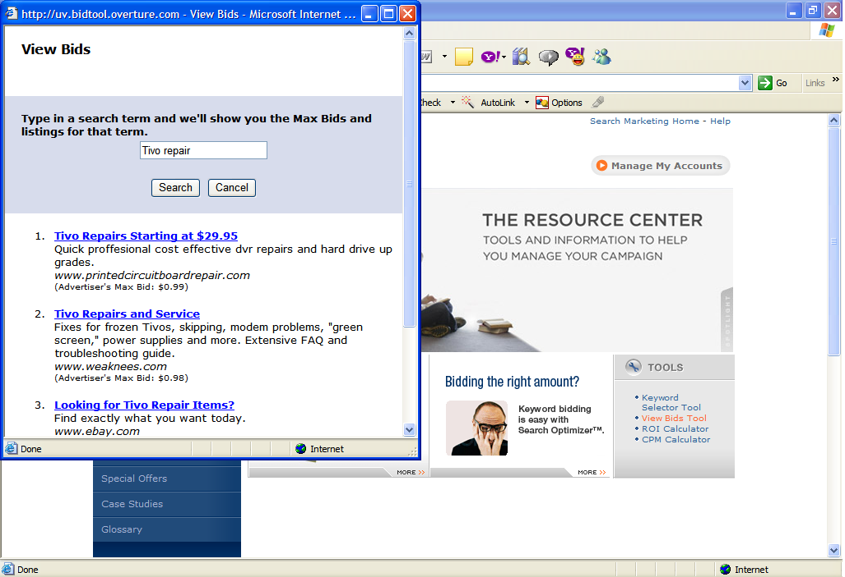

I want to make sure I won’t have to pay more than a dollar or two per click on average, but of course what you can profitably pay for PPC will depend on your product’s selling price and how many you can sell.

Again, at this point I’m just trying to get a snapshot or pulse of this market.

Plus, the bid process also tells you a little about the moneymaking opportunities of a market. As a loose rule, if the max bid results are between 30 cents and $2.00, it’s a good indicator that people are making money in this market. I call this my “magic window.”

Over $2.00 means that the competition is too fierce for my tastes, but depending on your market and eventual product selling price and demand, it may make sense for you.

To check on the companies that are bidding on my keywords in Google Adwords, I use http://www.googspy.com.
One relative newcomer as a research tool is Google Trends (http://www.google.com/trends).

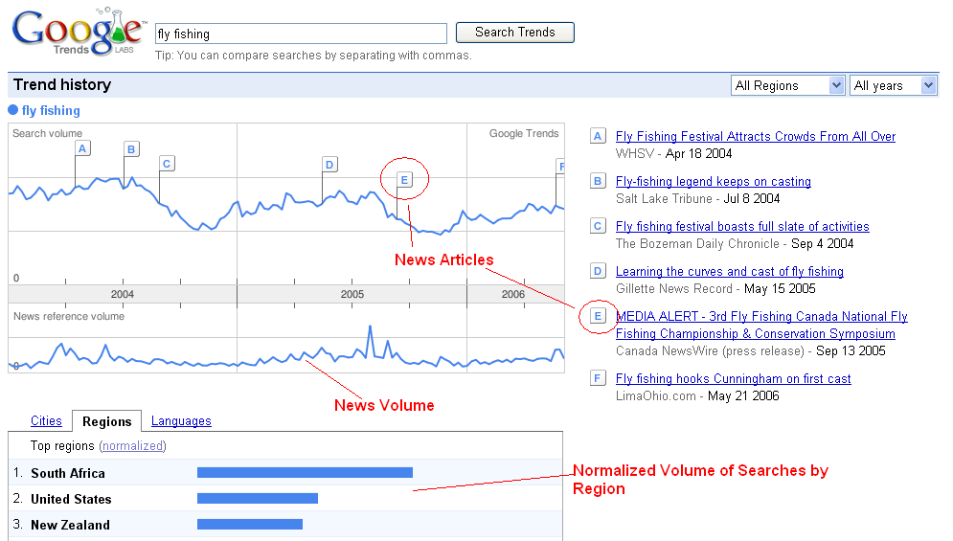

There’s lots of useful information here. You can see that the news volume is synced with the search volume, and several notable news articles are displayed, along with where they occurred on the timeline.

In the lower section, you can see which countries, cities, and languages made the most searches. Be aware that the indicators are normalized, meaning they are adjusted for that region’s population. For example, South Africa has about 44 million people, compared with the U.S.’s 295 million. So the U.S. may have performed more actual searches, but after the adjustment is made, South Africa comes on top for this search term, which is “fly fishing.”

In the upper-right corner of the page, you can switch regions (e.g. if you wanted to check the U.S. only), and you can change the time period.

For example, notice below how I changed the time period to a single month. See any cyclic trends there?

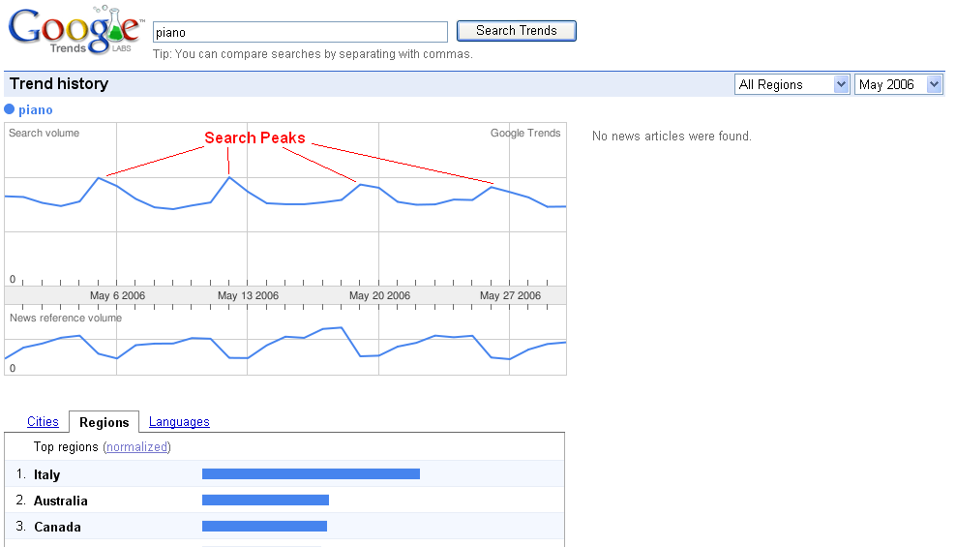

You may have noticed that searches for this topic tend to spike every Friday, going into the weekend, and then fall again during the week.

This information may be useful if you are going to advertise with Google Adwords, and you’re launching a firesale or other limited time campaign, because you’ll want to schedule your campaign around one or more of those spikes.

Some markets have different patterns, so it’s useful to be aware of them prior to launch.

Another great use for Google Trends is if you are trying to decide between two different niches. If you enter your search terms and separate two or more with a comma, Google will compare them for you.

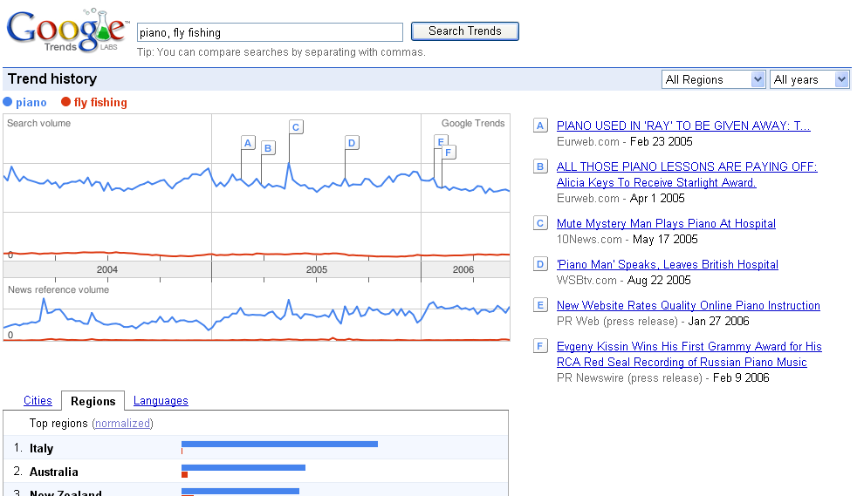

Very useful.

The work is already done for you. You just need to put it to good use. As you can see above, piano is too broad a niche. It has a high amount of searches, but the bids for PPC traffic is too low. As a result, I would suspect that people are generally not making a lot of money with that search term.

Remember, high volume + low PPC bids = low click through rates and even lower conversions.

Fly fishing, on the other hand, does have PPC bids between 30 cents and $2.00, so money is likely being made there. However, the search term itself is too low. Unless you have other keywords for that niche to add additional traffic, I would steer clear from there as well.

There are several other sites I use as well to get niche ideas, and especially to narrow the niche and discover potential information the market wants:

Nichebot - http://www.nichebot.com

Shopping.com Top Searches –
http://www2.shopping.com/top_searches

AOL Hot Searches - http://hot.aol.com/hot/hot

Google Groups - http://groups.google.com

Craig's List - http://www.craigslist.com

Delicious Popular - http://del.icio.us/popular

Dig - http://www.digg.com

Google Catalogs - http://catalogs.google.com

Google Suggest –
http://www.google.com/webhp?complete=1&hl=en

Technorati - http://www.technorati.com

Also, I'll do several targeted searches in both Google and Yahoo (for example, on the subject of "hobbies").

Finally, I’ll see what existing digital products are being sold in my target niche at the Clickbank Marketplace

(http://marketplace.clickbank.net).

HINT: If you want to see how your competitor’s sale pages have evolved over time, the Wayback Machine is a great place to do so (http://www.archive.org).

And of course I will always Google my keywords and check out the competition in the Adwords ads. In this case I pay special attention to the ads that sell information products (or services like mine if I’m selling a service).

Some of the ads will be irrelevant as far as competition goes.

Ok, the next thing I'll do is check how many magazines there are on the subject of my chosen niche.

There are two places I go online for that:

Magazines.com - http://www.magazines.com

and

Amazon –
http://www.amazon.com/exec/obidos/tg/browse/-/599858/

At each site, I search by category to find the magazines in my niche.

Obviously the more the better, up to a point.

For example, golf has a lot of magazines, but it's not a good niche by itself. It needs to be more targeted. But in that case I can always get more targeted sub-niche ideas within that topic by looking at the types of magazines for that topic.

Now, as good as these sites are for finding magazines, I'm still going to need to go to a bookstore that carries lots of magazines and browse through the ones in my niche?

Why?

Because I want to see what kinds of ads are in them.

I need to know who else is selling what, and it will also tell me whether the people in this niche spend money. And the ads will not only tell me that, but they will also tell me what the people in this niche spend their money ON. And if I want to know which ads keep appearing (because then I'll know they are making money), I would want to pick up several issues in a row of the same magazine, if possible.

Ok. By now I should have a pretty good niche market to test. And by knowing what kinds of informational products are selling, I can start to formulate the content I’m going to use for my test.

This is where I go to niche-specific sites.

So I’ll set up a mini-course on my autoresponder with my content.

I like mini-courses better than just a free report to get them to opt in, because the free report is a one shot deal. I want to “train” them to be on the lookout for my emails, to anticipate them and open them. That way when (or if) my offer shows up in their inbox, it may have only been a day or two since they last heard from me, not weeks or months ago when they got their free report (in that case they’ll likely forget they signed up for your list and promptly delete your offer, unsubscribe, or report it as spam).

If I have a free report I want to use, I’ll simply break it up for my mini-course. But as this is a new niche, it’s unlikely I’ll have a report yet.

I’ll then set up some very targeted PPC ads using Adwords.

I want to match each ad group to the keywords as closely as possible.

Then I turn it all on and start building my list.

So where’s the product, you ask?

Well, at this point, I don’t know for certain how much traffic I’ll get or whether they’ll opt in or not, never mind whether they will purchase my product. I have an idea, due to my research.

But now we want hard numbers to back it all up before I invest any more of my time and money. Hence, the testing.

There are two things I primarily watch as the list begins to build:

- How much traffic I am getting from PPC. I want to compare what I’m getting with my previous Overture estimates (adjusted for Google). At this point I want real numbers, not estimates.

- My opt in percentage. If it’s too low, either my squeeze page copy needs to be tweaked, or, if I’ve done my homework with my copy, perhaps this market is not made up of enough buyers.

Listen, if they’re not going to opt in, they’re certainly not going to buy.

Now if my traffic and opt ins are both good, now is the time to start thinking about a product, which ideally should be along the same lines as the content they signed up for in the first place.

Sometimes I will even email my list at this point and simply ask them what they want, or try to determine their wants and needs from carefully constructed survey questions. Just remember that people often say one thing and do another. It’s only 100% accurate when they vote with their wallets.

An even better way to test your list’s desire for a particular piece of information is to announce a free teleseminar to them, then see how many show up. If a large percentage of your list calls in, it’s a good bet they’re interested in your call topic.

HINT: Teleseminars also make GREAT products or bonuses themselves if you record them and sell them after the fact. In fact, sometimes I’ll announce a paid teleseminar rather than a free one.

Why?

Because then I know people will pay money for that information, an even better test indicator. They are voting with their wallets. Plus I can always sell the call recording after the fact as well.

Another technique to test whether this niche is built up of buyers or tire-kickers and freebie seekers is to promote an affiliate product within that niche.

If the product content is similar in nature to what you want to create as your product, it’s a good indication that you have the potential to get a similar percentage to buy yours. Just make sure it’s either a non-competing product or a front-end sale. If it’s a front-end sale, you’ll develop a mid or back-end product.

Bear in mind that in the case of the latter, you’ll get less of a percentage to buy (compared with the percentage who bought your affiliate front-end product), but you may make up the difference and then some with a higher ticket item. It’s a risk, but it should be a calculated one.

The beautiful thing is, once I confirm a niche will be profitable, with this approach I already have a pre-built list that keeps getting bigger by the time I launch the product.

So there you have it.

There are plenty of sites I use for research in addition to the ones above, but they are usually niche specific. These sites will help you to research practically any niche market effectively. Once you have this process down, you’ll be able to do this very quickly.

After all time is money.

